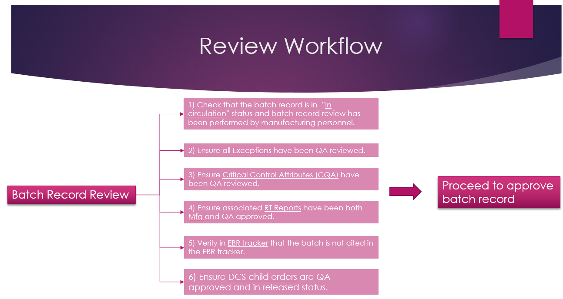

Requirements and proposed workflow

**Bot action steps for Manufacturing Order QA review**

**1st Search**

* Open Spotfire (PQA smartsheet) use link - [MO and Exception Tracker (PQA) - cached – TIBCO Spotfire (amgen.com)](https://spotfire-val.amgen.com/spotfire/wp/analysis?file=/Process%20Development/EDL/Workspace/ASM/Quality%20%28Not%20Validated%29/MO%20and%20Exception%20Tracker%20%28PQA%29%20-%20cached&waid=4ZrQUsI-40yw8bcDWtoxc-3108371d359UcZ&wavid=0) using Chrome browser
* Uncheck ‘Released’ & ”Drafted” under Select BRR Status

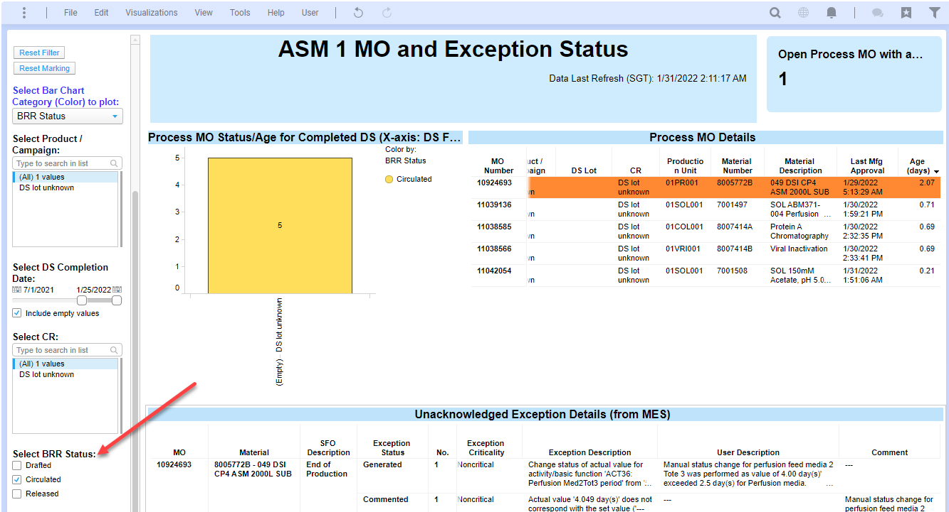

* Extract following information from “Process MO details’ table from **each** MO and transcribe to Excel sheet  
  - *Production unit  
  - MO number  
  - Material Number  
  - MO state  
  - Exceptions*

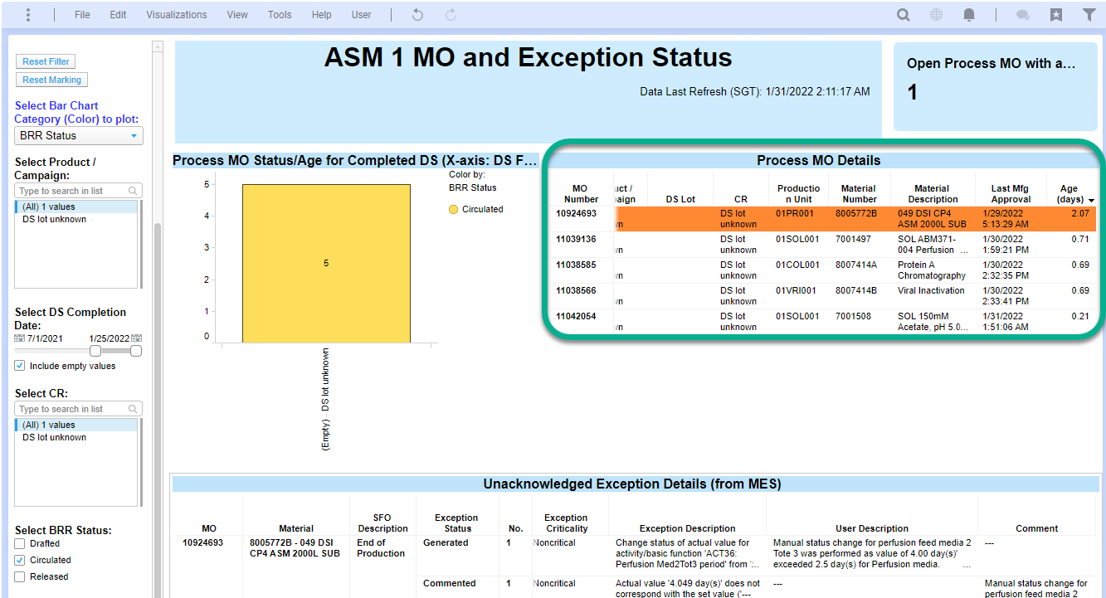

* If Exceptions exists
* Indicate in excel file
* Copy ‘MO ID’
* Open ‘EBR Tracker’ link - [EBR Performance Tracker.xlsx (sharepoint.com)](https://amgen.sharepoint.com/:x:/r/sites/ASMMFG/_layouts/15/Doc.aspx?sourcedoc=%7B02C66B4A-1554-4AC5-ABAA-83AA3CC81395%7D&file=EBR%20Performance%20Tracker.xlsx&action=default&mobileredirect=true&cid=614bf27f-ee20-4ae0-a2e5-c43a78c75f4a)
* Navigate to process stream e.g., ‘Exception(Sol)’
* Remove all filters from all columns
* Enable all filters on ‘Status’ column except ‘Acknowledged’

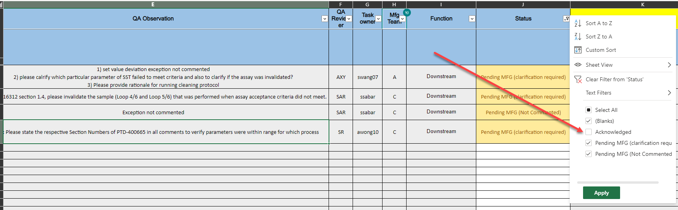

* Search copied MO ID number
* Indicate in excel file if the exception has been cited in EBR tracker

**2nd Search (RtReport)**

First Filter

* Copy Batch ID ** not displayed yet (to request inclusion of Batch ID in Spotfire)
* Open RtReports link - [RtReports Batch Search (amgen.com)](https://sgsg-pweb-rtr01.sg.amgen.com/RtReports/Webpages/BatchSearch.aspx)
* Log in
* Edit start time to ‘*-30d’
* Paste Batch ID into ‘Batch column’ followed by ‘*’ (first filter)

Second Filter

* From the Material Number extracted previously, obtain the corresponding recipes found in APPX-451110
* Populate Recipe name in the second filter

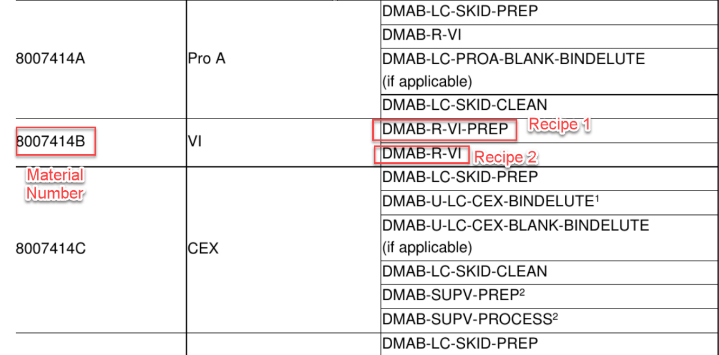

(This step will require assistance)

* Click ‘Reports’

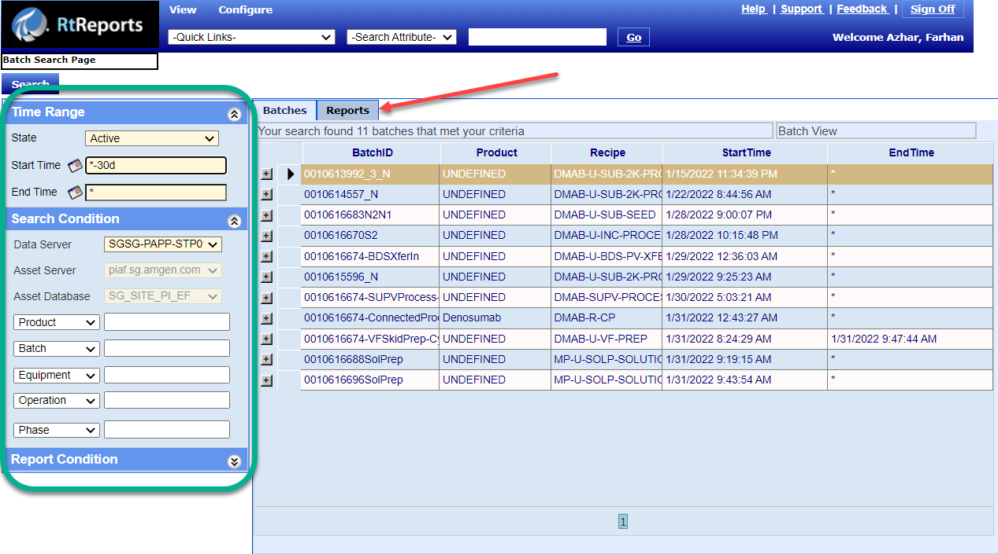

* Check RtReport status is ‘Approved’ or ‘In circulation’
* If status is ‘In circulation’,

Open rtreport

Scan for ‘ack/unack’

Sum value of ‘ack/unack’ found

Scan for phase events, active step changes – (*No* phase events/active step change = clear)

* If status is “Approved”
* Indicate in excel file
* Repeat until all MOs has been completed.

Goal - Report to display to user the overall status of an MO and determine if it is ready to be released or pending approval or comments from exception/Child order/RtReports

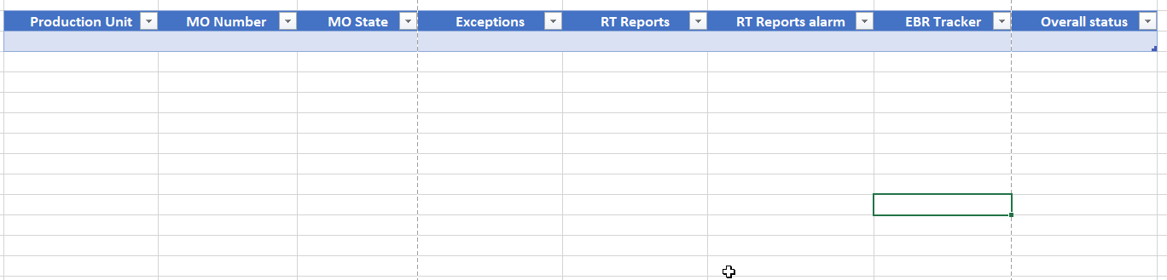

In summary, gather information from Spotfire + EBR Excel Tracker + RtReport data = Consolidate in Excel or Smartsheet

Data to be archived once completed in a different file

Steps for ESPs are similar hence, the entire framework remains the same.